CHAPTER 4
COMPARATIVE ANALYSIS AND FINDINGS

4.1 Introduction
This chapter presents the core comparative analysis of this dissertation, evaluating Azure Functions (serverless) and Azure Kubernetes Service, AKS (container-based) across four parameters: cost, performance, scalability, and reliability. The analysis is grounded exclusively in data from peer-reviewed research, Microsoft Azure official documentation, and published technical benchmarks, maintaining the controlled, within-Azure scope established in the research methodology. Each parameter is examined through a dedicated section, presenting findings from the literature and synthesising them into structured comparisons supported by visual data representations. A consolidated summary table is presented at the end of the chapter.

4.2 Parameter 1: Cost Analysis

4.2.1 Azure Functions — Cost Model
Azure Functions operates on a pay-per-execution billing model under its Consumption Plan. Microsoft charges based on two metrics: the total number of function executions per month, and resource consumption measured in gigabyte-seconds (GB-s). The Consumption Plan includes a free tier of one million executions and 400,000 GB-s per month, after which charges apply per additional execution and per GB-s consumed (Microsoft Azure Documentation, 2024). This structure makes Azure Functions inherently cost-efficient for workloads characterised by sporadic invocations or low duty cycles. Critically, Azure Functions incurs zero cost during idle periods under the Consumption Plan, as no resources are provisioned when no functions are executing.
For workloads requiring consistent performance, the Premium Plan charges on a per-vCPU and per-memory basis continuously. For example, the Premium V4 tier costs approximately .128 per hour per instance, amounting to approximately ,532 per month for a single always-on instance (Microsoft Azure Pricing, 2024).

4.2.2 AKS — Cost Model
AKS follows a continuous node provisioning billing model. Production workloads requiring a financially backed SLA must use the Standard tier, which charges approximately /bin/sh.10 per cluster per hour for the control plane, totalling approximately 2 per month per cluster regardless of utilisation (Microsoft Azure Documentation, 2024). Worker nodes are billed continuously based on VM type and uptime. A minimal production cluster comprising three Standard_D2s_v3 nodes incurs approximately 10 per month in node costs alone, resulting in a baseline of approximately 82 per month before storage or networking charges.

4.2.3 Cost Comparison by Workload Scenario
The cost comparison between Azure Functions and AKS is highly workload-dependent. Figure 4.1 illustrates estimated monthly costs for both architectures across three representative workload scenarios, based on pricing data from Microsoft Azure Documentation (2024) and the empirical cost findings of Hamza et al. (2024).

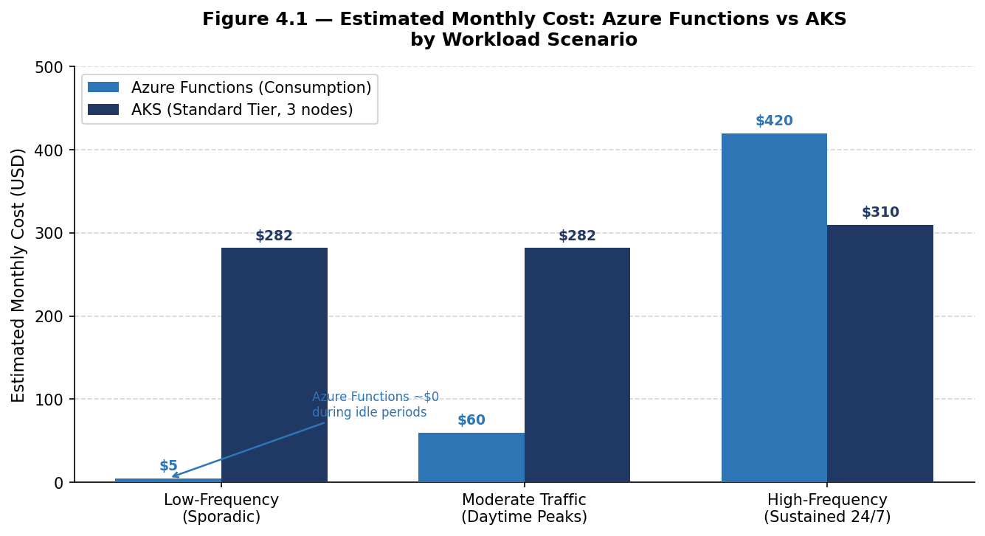
Figure 4.1 — Estimated Monthly Cost: Azure Functions vs AKS by Workload Scenario
Figure 4.1 clearly demonstrates that Azure Functions provides a significant cost advantage for low-frequency and sporadic workloads, approaching near-zero cost during idle periods, while AKS maintains a fixed baseline cost of approximately 82 per month regardless of workload activity. The cost curves converge and eventually cross at high-frequency sustained workloads, where the per-execution charges of Azure Functions accumulate to exceed the fixed node costs of AKS, particularly when AKS benefits from reserved instance discounts.

Table 4.1 summarises the cost characteristics across workload scenarios.

Workload Scenario | Azure Functions | AKS
Low-frequency / sporadic | Cost-effective — pay per execution; scale to zero | Expensive — nodes run continuously at fixed cost
Moderate traffic (daytime peaks) | Cost-effective — auto-scales with demand | Moderate — cluster autoscaler reduces idle costs
High-frequency / sustained 24/7 | Can be expensive — per-execution charges accumulate | Cost-effective with reserved instances
Idle / zero traffic | Zero cost under Consumption Plan | Fixed node costs continue
Table 4.1 — Cost Comparison of Azure Functions and AKS by Workload Scenario

Figure 4.4 provides a further breakdown of the AKS monthly cost structure for a minimal production cluster, illustrating how the continuous billing model distributes across its primary cost components.

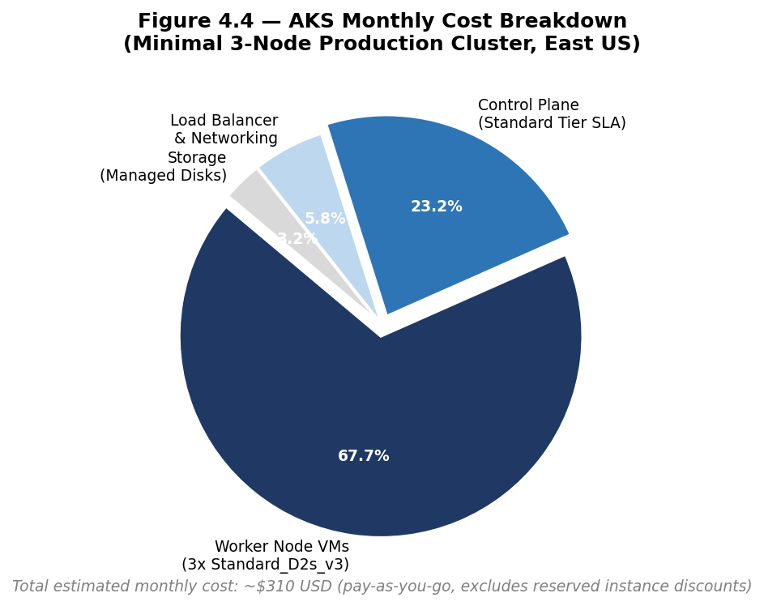
Figure 4.4 — AKS Monthly Cost Breakdown (Minimal 3-Node Production Cluster, East US)
As Figure 4.4 illustrates, worker node VM costs represent the dominant component of AKS expenditure at approximately 68% of total monthly cost, followed by the Standard tier control plane SLA fee at approximately 23%. This cost structure is fixed and continuous, underscoring the importance of workload profiling before committing to an AKS deployment.

4.3 Parameter 2: Performance Analysis

4.3.1 Azure Functions — Performance and Cold Start
The primary performance challenge of Azure Functions is cold start latency. A cold start occurs when a function is invoked after a period of inactivity, requiring the platform to provision a new execution environment before processing the request. Microsoft targets cold start latency of a few hundred milliseconds at the 50th percentile and under one second at the 99th percentile (Microsoft Azure Engineering Blog, 2024). However, Golec et al. (2024) and broader research demonstrate that cold start latency can range from hundreds of milliseconds to over seven seconds in worst-case scenarios depending on runtime complexity and dependency load.
Shahrad et al. (2020) found that the majority of Azure Functions are invoked infrequently with highly variable inter-arrival times, meaning that a substantial proportion of real-world invocations are subject to cold starts under the Consumption Plan. Warm execution latency, by contrast, is near-instantaneous and comparable to container-based workloads.

4.3.2 AKS — Performance Characteristics
AKS container-based workloads do not suffer from cold start latency provided a minimum number of pod replicas are maintained in a running state. Response latency is consistent and predictable, constrained only by application processing time and network overhead (Microsoft Azure Documentation, 2024). However, AKS introduces its own latency concern during scale-out events: when existing nodes are fully utilised, the Cluster Autoscaler must provision new VM nodes, a process that can take several minutes — a latency analogous in operational effect to serverless cold starts.

4.3.3 Performance Comparison
Figure 4.2 provides a visual comparison of latency profiles across both architectures, plotted on a logarithmic scale to accommodate the wide range of values.

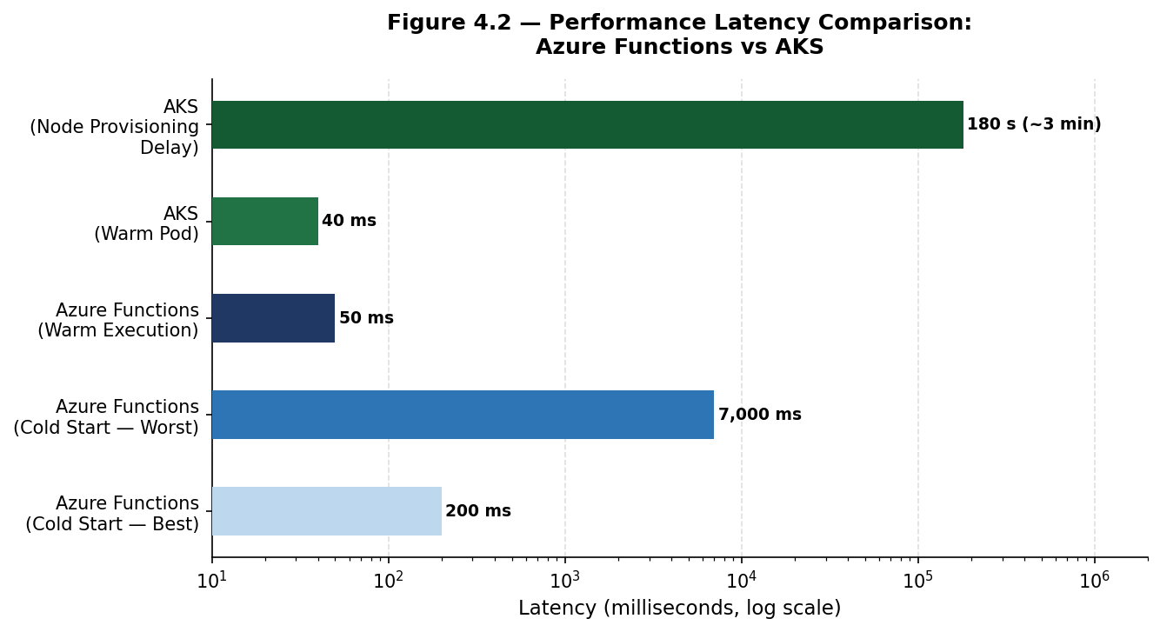
Figure 4.2 — Performance Latency Comparison: Azure Functions vs AKS (Log Scale)
Figure 4.2 highlights the significant latency variability introduced by Azure Functions cold starts, which can range from 200 milliseconds in the best case to over 7,000 milliseconds in the worst case, compared to AKS warm pod latency of approximately 40 milliseconds. Notably, AKS node provisioning delay during scale-out events can reach 180,000 milliseconds (three minutes), illustrating that both architectures exhibit latency spikes under specific conditions — a nuance often overlooked in the existing literature.

Performance Metric | Azure Functions | AKS
Warm latency | Near-instant; comparable to containers | Consistent; always-warm containers
Cold start latency | 200ms to 7s+ (Consumption Plan) | No cold starts with minimum replicas
Latency predictability | Variable under Consumption Plan | Highly predictable
Scale-out latency | Near-instant function-level scaling | Node provisioning: up to 3+ minutes
SLA suitability | Premium Plan required for strict SLAs | Standard Tier: 99.9–99.95% uptime SLA
Table 4.2 — Performance Comparison of Azure Functions and AKS

4.4 Parameter 3: Scalability Analysis

4.4.1 Azure Functions — Scalability
Azure Functions scales automatically at the function execution level, driven by the Azure Scale Controller which monitors event trigger rates. Under the Consumption Plan it supports native scale-to-zero — de-provisioning all instances during idle periods — and scales out within seconds in response to demand spikes. This bidirectional scaling requires no manual configuration, making it particularly well-suited for event-driven, burst, and unpredictable workloads (Microsoft Azure Documentation, 2024).

4.4.2 AKS — Scalability
AKS provides scalability through two complementary mechanisms. The Horizontal Pod Autoscaler (HPA) checks the Metrics API every 15 seconds and updates pod replica counts every 60 seconds based on CPU or custom metrics (Kubernetes Documentation, 2024). When existing nodes lack capacity, the Cluster Autoscaler provisions new Azure VM nodes, a process that can take several minutes. AKS supports significantly larger maximum scale than Azure Functions, supporting up to 5,000 nodes per cluster in the Standard tier, and can leverage KEDA for event-driven pod scaling analogous to Azure Functions.

4.4.3 Scalability Comparison
Figure 4.3 compares the time-to-scale for both architectures across key scaling scenarios.

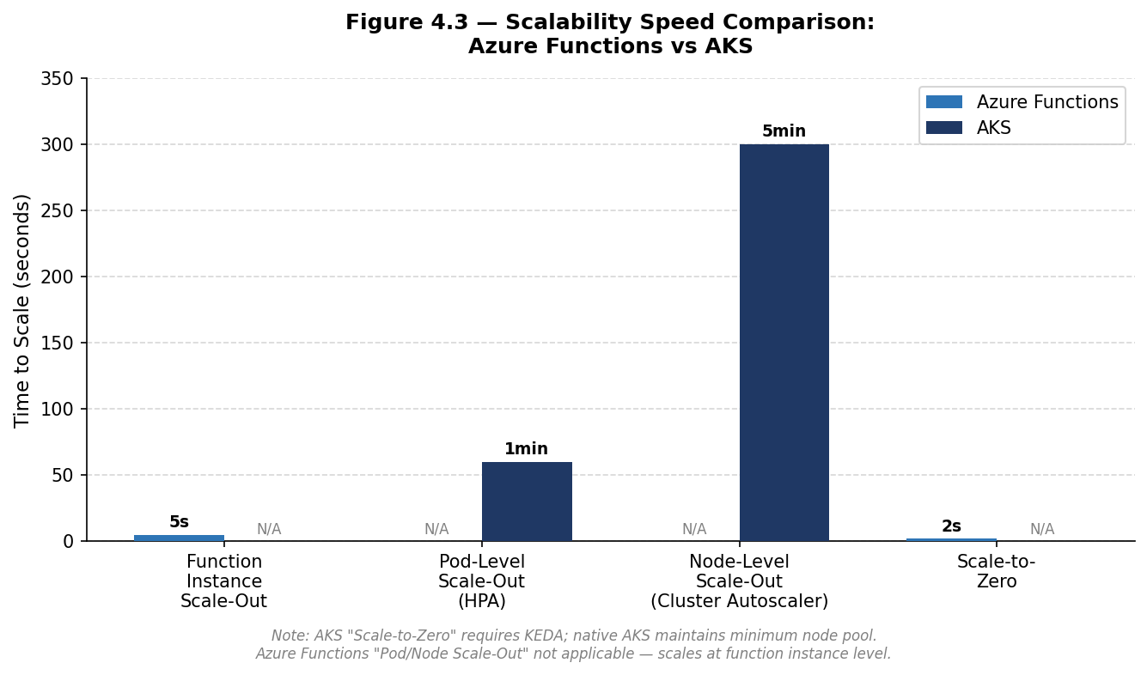
Figure 4.3 — Scalability Speed Comparison: Azure Functions vs AKS
Figure 4.3 illustrates that Azure Functions achieves function-level scale-out in approximately 5 seconds and scale-to-zero in approximately 2 seconds, compared to AKS pod-level scaling of 60 seconds via HPA and node-level scaling of up to 300 seconds via the Cluster Autoscaler. This demonstrates Azure Functions' clear advantage for rapid burst response, while AKS' multi-layered scaling architecture provides greater depth and control for large, sustained workloads.

Scalability Metric | Azure Functions | AKS
Scale-to-zero | Native; zero resources at idle | Not native; minimum node pool required
Scale-out speed | ~5 seconds (function-level) | 60s pod-level; 5+ min node-level
Burst traffic handling | Excellent for sudden spikes | Limited by node provisioning speed
Maximum scale | Default 200 instances (configurable) | Up to 5,000 nodes (Standard tier)
Event-driven scaling | Native — HTTP, Queue, Timer, etc. | Via KEDA integration on AKS
Table 4.3 — Scalability Comparison of Azure Functions and AKS

4.5 Parameter 4: Reliability Analysis

4.5.1 Azure Functions — Reliability
Azure Functions delegates infrastructure reliability entirely to Microsoft. The Consumption Plan does not offer a financially backed SLA, while the Premium Plan provides a 99.95% availability SLA (Microsoft Azure Documentation, 2024). The managed nature of the platform means platform-level failures are handled transparently, with configurable retry policies and dead-letter queue support for application-level failure handling. However, operators have limited ability to customise redundancy configurations or instance placement.

4.5.2 AKS — Reliability
AKS provides a richer and more configurable reliability model. The Standard tier delivers a financially backed 99.9% SLA, rising to 99.95% with Availability Zone deployment (Microsoft Azure Documentation, 2024). AKS supports Pod Disruption Budgets, liveness and readiness probes, and multi-zone node pool deployment. The 2024 Fairwinds Kubernetes Benchmark Report, based on data from over 330,000 production workloads, found that a significant proportion of Kubernetes deployments lack properly configured liveness probes and replica settings, highlighting that AKS reliability is operationally contingent on correct configuration.

4.5.3 Reliability Comparison
Reliability Metric | Azure Functions | AKS
Platform SLA | 99.95% (Premium); No SLA (Consumption) | 99.9–99.95% (Standard; Availability Zones)
Fault tolerance | Fully managed by Azure | User-configurable; rich fault tolerance options
Multi-zone support | Limited operator control | Native multi-zone node pool deployment
Operator control | Minimal — fully managed by Microsoft | High — full Kubernetes configuration access
Operational complexity | Low — no infrastructure to manage | High — requires Kubernetes expertise
Table 4.4 — Reliability Comparison of Azure Functions and AKS

4.6 Consolidated Findings: Summary Comparison
Parameter | Azure Functions (Serverless) | AKS (Container-Based)
Cost | Superior for low-frequency/sporadic workloads; zero idle cost under Consumption Plan | Superior for high-frequency/sustained workloads; predictable billing with reserved instances
Performance | Cold start latency (200ms to 7s+) under Consumption Plan; Premium Plan eliminates cold starts | Consistent latency; no cold starts with minimum replicas; node provisioning lag at scale-out
Scalability | Native scale-to-zero; ~5s scale-out; ideal for burst traffic; max 200 instances | 60s pod scaling; 5+ min node provisioning; superior max scale (5,000 nodes)
Reliability | Fully managed; 99.95% SLA (Premium); low operational complexity | Configurable; 99.9–99.95% SLA; high operator control; requires Kubernetes expertise
Best For | Event-driven, sporadic, cost-sensitive, operationally lean workloads | Sustained, latency-sensitive, large-scale microservices requiring fine-grained control
Table 4.5 — Consolidated Comparative Analysis: Azure Functions vs AKS within Microsoft Azure

4.7 Key Findings
Finding 1 — Cost is workload-dependent: Azure Functions provides a clear cost advantage for low-frequency, sporadic, or idle-heavy workloads due to its pay-per-execution model and scale-to-zero capability. AKS becomes more cost-effective for sustained, high-frequency workloads, particularly when reserved instance pricing is applied.
Finding 2 — AKS offers superior performance consistency: AKS provides more predictable and consistent response latency than Azure Functions under the Consumption Plan due to the absence of cold starts. Both architectures exhibit latency spikes under specific conditions — cold starts for Azure Functions, and node provisioning delays for AKS.
Finding 3 — Azure Functions scales faster but AKS scales larger: Azure Functions offers near-instant, automatic scale-out (~5 seconds) and native scale-to-zero, making it superior for burst traffic. AKS supports larger maximum cluster sizes (up to 5,000 nodes) and more granular scaling control for large-scale sustained workloads.
Finding 4 — Reliability is comparable but operationally distinct: Both architectures can achieve 99.9–99.95% uptime SLAs on Azure. Azure Functions achieves this through full platform management, while AKS achieves it through configurable, operator-managed mechanisms that require Kubernetes expertise.

4.8 Summary
This chapter has presented a systematic comparative analysis of Azure Functions and AKS across four parameters, supported by structured tables and data visualisations grounded in peer-reviewed research and official Azure documentation. The findings reveal that neither architecture is universally superior; each offers distinct advantages that make it more or less suitable depending on workload characteristics, performance requirements, and operational capabilities. These findings are interpreted in the broader context of the research questions in Chapter 5.

